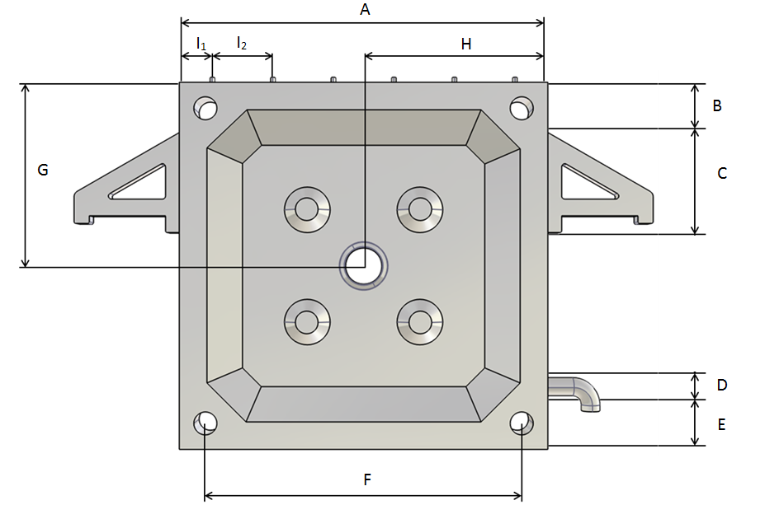
Plate measures: | A = mm.
Thickness | In the frame area = mm.
 | Of the feed hole = mm.
Collar type:
Barrel-neck material: |  |  |  |  |  |  |  |  | Describe .
Plate subjection: |  |  |  | B = mm. C = mm.
 |  |  |  | Describe position and measures.
Drain: |  |  |  |  |  |  | D = mm. E = mm.
 |  |  |  |  |  |  |  | F = mm. Diameter = mm.
Feed hole: |  |  | Diameter = mm.
 |  |  | Diameter = mm. G = mm. H = mm.
Upper pivots: | ☐Metallic |  |  | No. pivots: . Ø =Choose value.  I1 = mm. I2 = mm. I3 = mm.  I4 =0mm. I5 = mm. I6 = mm.  Observations.
Side eyelets: | ☐Metallic |  |  | : . Diameter =Choose value.
Bottom eyelets: | ☐Metallic |  |  | : . Diameter =Choose value.
Glued frame: |  |  |  |  |  | Frame Width = mm. Observations.
Others: | Describe .

